

**INTI INTERNATIONAL COLLEGE SUBANG JAYA**

**CENTRE OF AMERICAN EDUCATION (CAE)**

**INDIVIDUAL ASSIGNMENT 2 (10%)**

|  |  |  |  |  |  |
| --- | --- | --- | --- | --- | --- |
| Programme Name | **AMERICAN UNIVERSITY PROGRAM (AUP)** | | | | |
| Module Name | **OBJECT-ORIENTED PROGRAMMING IN JAVA I** | | Module Code | | **CSC200** |
| Session/Semester | | **Jan 2020** |
| Module Leader Name | **MR K. SHIVA** | | Assessment Type / Reference No. | | **ASSIGNMENT 2 / Jan 2020** |
| Student Name |  | | Student Matric No. | |  |
| Student’s declaration | I hereby certify that this assignment is my own work and where materials have been used from other resources, they have been properly acknowledged. I also understand I will face the possibility of failing the module if the content of this assignment are plagiarized.  Signed: ________________________ Date: _________________ | | | | |
|  | * **LOC 1**: Produce computer programs using control structures, data structures, methods, and classes. | | | | |
| Learning Outcomes (s) / | * **LOC 2**: Analyze object oriented programming concepts in programming problems. | | | | |
| Criteria | * **LOC 3:** Demonstrate information management and lifelong learning skills in developing computer program. | | | | |
| Release Date | **13.03.2020** | Submission Due Date on or before | | **03.04.2020 at 3PM-5PM, A-L4-CSC1** | **Marks obtained** |
| Date Received |  | Student’s work assessed by / date | |  |

ASSIGNMENT SCENARIO

Create java programs to the following scenario by using appropriate *comments, variable usage, program logic, I/O statements, looping structure, more interactive and user friendly.*

**Task 1 (30%):**

A large company pays its salespeople on a commission basis. The salespeople receive $**200** per week plus **9**% of their gross sales for that week.

For example, a salesperson who sells $**5000** worth of merchandise in a week receives $**200** plus **9**% of $5000, a total of $650.

You have been supplied with a **list of items** sold by each salesperson (assume that there are more than THREE (3) sales persons, and required to calculate to **ALL** the sales person’s gross sales). The values of these items are as follows.

|  |  |
| --- | --- |
| **Item** | **value** |
| **1** | **244.50** |
| **2** | **125.75** |
| **3** | **323.33** |
| **4** | **46.29** |
| **5** | **3323.65** |

Develop a Java application that inputs one salesperson’s items sold for last week and calculates and displays that salesperson’s earnings; once done, next sales person and so on. There is **no limit** to the number of items sold by a salesperson. Finally, need to display the receipt which contains all the details (All the salespersons details). However, you are encouraged to provide other functionalities in order to score well in this task.

**Sample Output** (Just an assumption, but not limited):

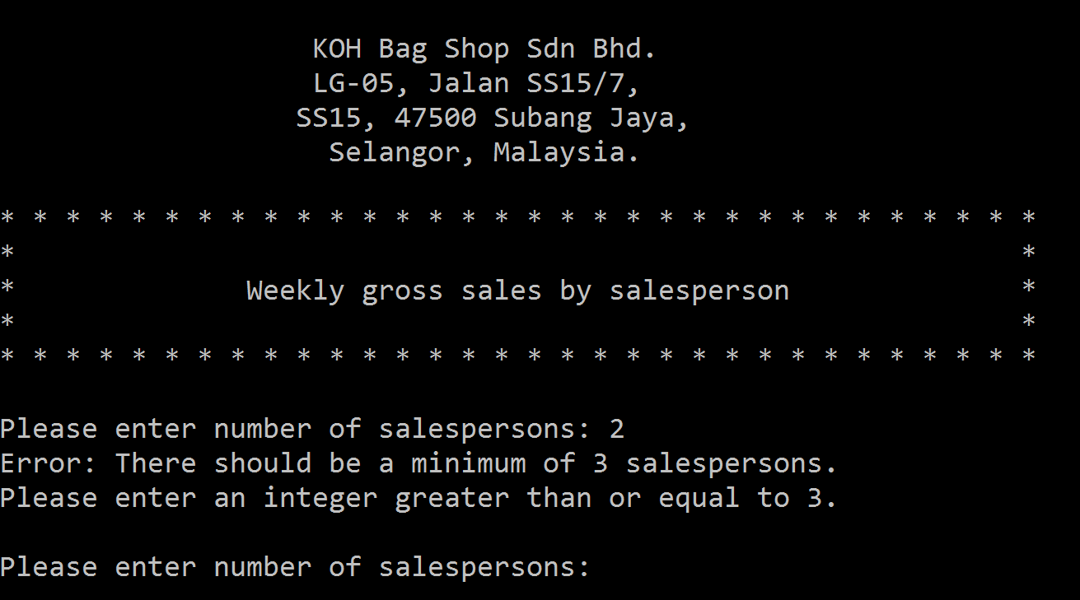

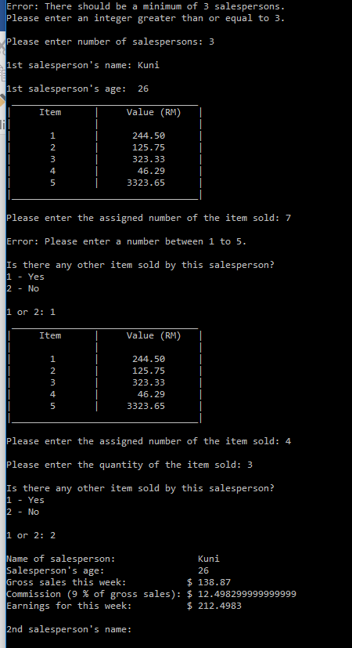

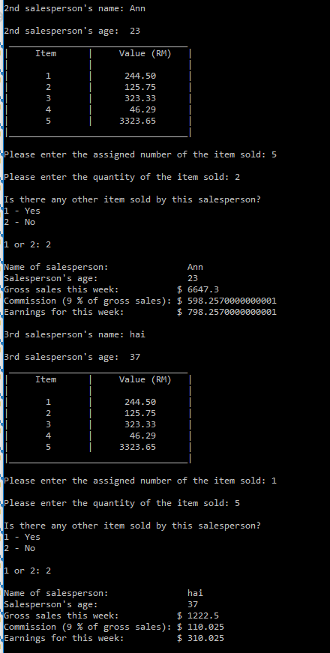

**Note: Required to provide All the salesperson details in your final receipt.**

**Grading Rubrics**

|  |  |  |  |  |
| --- | --- | --- | --- | --- |
| (**Outstanding)** | **(Excellent)** | **(Good)** | **(Fair)** | **(Poor)** |
| Basic requirements, execution, logic, validation, runtime, critical thinking, including additional functions (24-30). | Program executes correctly with no syntax or runtime errors, validation, creativity of application (20-23) | Meet the basic requirements but acceptable. No syntax, runtime, logic error (15-19) | Program executes with a minor (easily fixed error) (10-14) | Program does not execute (0-9) |
|  |  |  |  |  |
| **TOTAL** |  |  |  |  |

**Task 2 (70%) – With reference of Peer Assignment 1 in task 2, you are required to design and develop a following using** Java applicationwhich performs the following tasks:

1. Display the welcome screen once the programs run. The sample output has been given below. However, you can create your own.

**Sample welcome screen output:**

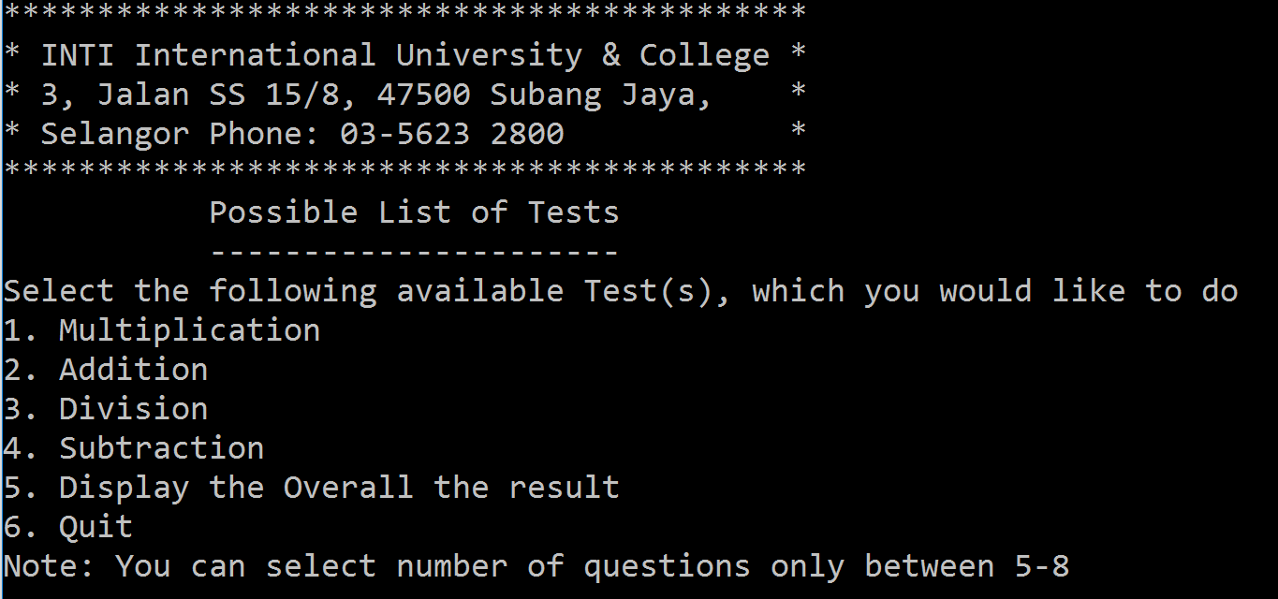

1. Initially user need to select an option from 1 to 4; if the user selects the option which is not appropriate then ask the user to select a right option until an appropriate selection.
2. If user selects option number 1, then it will ask you type your name and number of questions you would like to test as shown below.

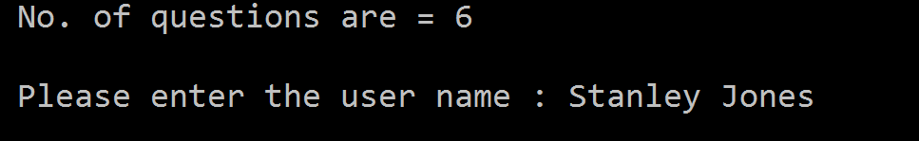

1. You can create 2 variables, and assign them random integers and **which randomly generates two-digit integers namely number_one and number_two.**
2. **To makes sure that number_one must be greater than or equal to number_two and displays a question such as “What is 78 * 71?” to the user. After the user types the answer, the program displays whether the answer is correct or not. If incorrect print message with what the problem was and the correct number.**

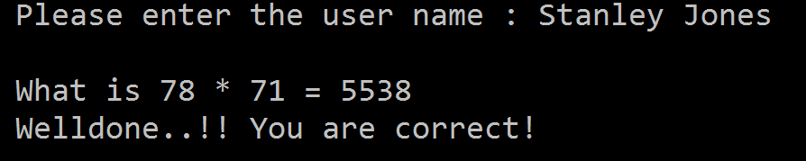

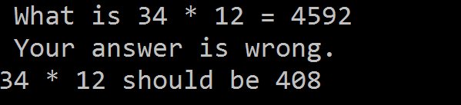

1. **It will continue until the user chosen number of questions (The number of questions are 5 to 8).**

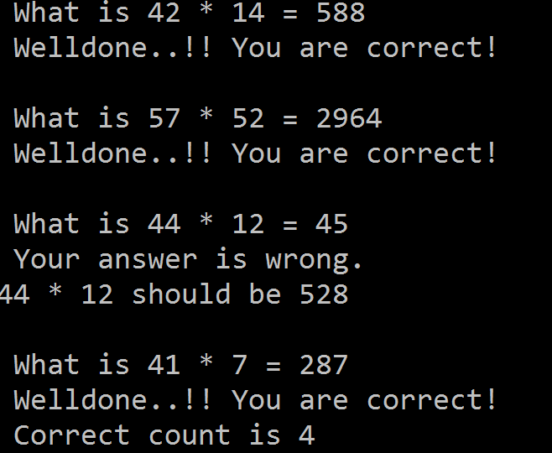

1. **Once answered by the user, the system need to generate the results (the list of questions and corresponding answer given by user).**

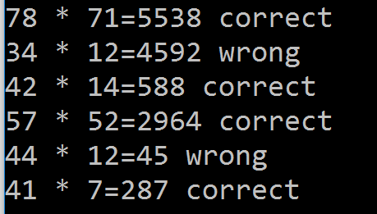

1. **How many seconds has been taken to accomplish the entire questions?**

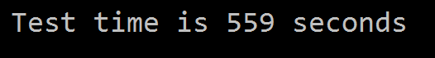

1. **On every subsequent selection, your program to require to ask the user to continue the next selection or need to quit.**
2. **Upon completion of All the tests (1-4 option, however it depends on the user he/she may select other option). The system need to generate overall result taken by a particular user.**

**Grading Rubrics**

|  |  |  |  |  |
| --- | --- | --- | --- | --- |
| (**Outstanding)** | **(Excellent)** | **(Good)** | **(Fair)** | **(Poor)** |
| Basic requirements, execution, logic, validation, runtime, critical thinking, any other additional functions (55-70). | Program executes correctly with no syntax or runtime errors, validation, creativity of application (45-54) | Meet the basic requirements but acceptable. No syntax, runtime, logic error (35-44) | Program executes with a minor (easily fixed error) (10-34) | Program does not execute (0-9) |
|  |  |  |  |  |
| **TOTAL** |  |  |  |  |

**Instructions to Students:**

During the execution of your program, the following criteria must be met:

* All classes must compile, & program must not generate a runtime error. Must meet all assignment requirements.
* The assignment must produce accurate results. The program must accurately represent the sample output provided to you as a minimum requirement.
* Submit soft copy of your work (which contains all tasks,) on **pen drive** and **Black Board (safeassign link)**.
* Submit your work to your instructor before or on published deadline & **ZERO (0)** marks for late compliance.
* You are required to Demonstration of the Java Codeand **viva-voce.** If failed to present, your assignment work will become **NULL** and **VOID.**